**HUMANITIES CONNECTIONS TO LITERATURE**

|  |
| --- |
| **HUMAITIONS CONNECTION ASSIGNMENT PART 1**  The following is a non-fiction article that gives you an overview of historical events described in *They Called us the Enemy*. When reading about historic events, non-fiction can provide additional historic context or background evidence that can enhance your understanding of the story. Read the article below and answer the guiding questions provided. |

# **Franklin D. Roosevelt Signs Executive Order 9066**

# 

# **More than 100,000 Japanese Americans were "interned" during World War Two**.

# 

# In 1941, a major war was being fought between the Axis nations of Germany, Japan, and Italy, and the Allies, which included France, England, Canada, and the Soviet Union. The U.S. did not enter the war until after December 7, 1941. On that day, the nation of Japan attacked the naval base at Pearl Harbor, Hawaii. After this attack, U.S. President Franklin D. Roosevelt asked Congress to declare war against Japan. A couple of months later, President Roosevelt took another step that changed the lives of Japanese Americans forever.

At the outbreak of the war, about 110,000 Japanese Americans lived on the West Coast. About 65 percent of them were already U.S. citizens. But government officials worried that Japan would invade California, Oregon, or Washington. Some of President Roosevelt's advisors warned him that Japanese Americans might sabotage, or purposely do damage to, war efforts. On February 19, 1942, President Roosevelt signed Executive Order 9066. This order authorized the U.S. military to take charge of any group of people that might be a threat during wartime. The order did not mention Japan or Japanese Americans. But the whole idea behind it was to remove people with Japanese ancestry from the West Coast.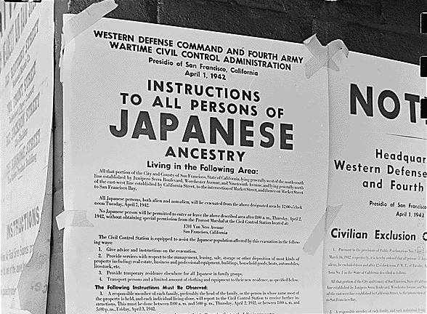

|  |
| --- |
| 1. **What was the reason given for the Executive Order 9066 being issued?** |

Starting in April of 1942, signs were posted in San Francisco, Los Angeles, Seattle, Portland, and other cities where Japanese people had settled, instructing people to gather up their belongings and move away. They had to leave their businesses, homes, and most of their possessions behind. Some were able to start over in other communities. But some of these communities started refusing to admit anyone of Japanese ancestry. So families with nowhere to go were rounded up and sent to military-run internment camps. Internment means imprisoning people in large groups without trials. One of these families was the Mochida family from California. Mr. Mochida was a successful farmer and business owner, who, like many others, lost all of his property. More than 100,000 people of Japanese descent were sent to the internment camps. Most were U.S. citizens.

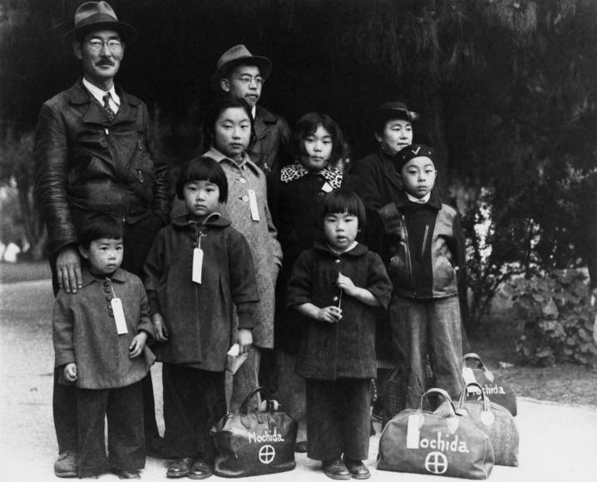

The internment camps were not run exactly like prisons. Families could stay together. They could play baseball and other games, and they ran their own communities like small towns. But the interned people were not really free, either. No one was allowed to speak Japanese, supposedly to keep them from plotting against the U.S. No one was permitted to leave the grounds, except to go to a hospital. The facilities were horrid. The temporary housing used tarpaper for walls and had neither running water nor cooking facilities. Many people got sick due to the unsafe conditions.

The internment camps were closed starting in January of 1945, after a court decision saying that the government could not lock up loyal U.S. citizens. Japanese Americans were allowed to go back home. For most of them, however, there was no home to go back to. Many families' homes and businesses had already been confiscated, or taken from them. It is estimated that Japanese Americans lost property worth well more than $400 million during this time. Many had lost their jobs as well, some simply for being Japanese during wartime.

|  |
| --- |
| 1. **What challenges faced Japanese Americans after being released from the internment camps?** |

In 1976, President Gerald Ford officially rescinded, or took back, Executive Order 9066. And in 1989, President George H.W. Bush signed an order to compensate families who had been interned in the camps, for the loss of their land and possessions.

|  |
| --- |
| 1. **The last paragraph refers to an order to “compensate” or repay those who had been interred in the camps. This repayment included $20,000 to each individual who were interned. Do you think the apologies and repayment made up for what happened to the interned people?** |

Article Source: NewsCurrents Read to Know, Feb 16, 2015

. 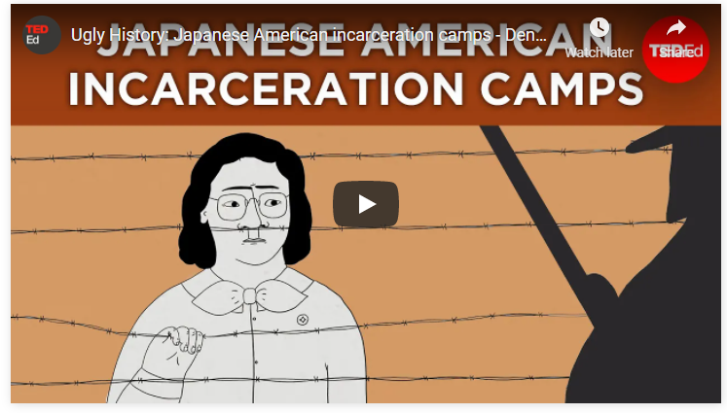

|  |
| --- |
| **Watch** [**this video**](https://youtu.be/hI4NoVWq87M) **that expands on the history and effects of Executive Order 9066 and incarceration of Japanese Americans. After you watch answer the following questions:**   1. **What additional information did the video give you that you think is valuable to understanding the problems faced by those who were forced to live in the camps?** |