**HUMANITIES SUMMER START**

|  |
| --- |
| **HUMANITIES ASSIGNMENT PART 1**  In 6th Grade you will begin to learn more about the world, its people, and its history though your studies in Humanities. This is an important field of study because by understanding the world it helps us understand ourselves and prepares us to make the best choices for the future. Next year, your class will focus on learning world geography. All parts of the summer assignment are designed to get you ready with a review of basic information and beginning skills practice.  Geography is the study of places and the relationships between people and their environments. Geographers explore both the physical properties of Earth’s surface and the human societies spread across it. They also examine how human culture interacts with the natural environment, and the way that locations and places can have an impact on people. Geography seeks to understand where things are found, why they are there, and how they develop and change over time.  Maps are the main ways that geographers communicate information. This assignment will help you learn some of the basics and practice reading maps. |

**Where in the World Are You?**

Where are you in the world right now? You are probably in your home. Your home is in a neighborhood in a city. Your city is in a state. The state is in a country. And your country is on a continent. Seven continents cover Earth. Whew! Now where, exactly, did you say you were?

People need to be able to describe where they are located. Sometimes you need to describe approximately where you are. Sometimes you need to describe exactly where you are. Because of this, people have found ways to describe their position on Earth. More than 4,000 years ago, people began using maps to show what the world looked like. Maps are information tools. We can use maps to find and study certain places.

Maps are models of Earth and its features. People who make maps are called cartographers. These map makers use points, lines, symbols and color to explain details on the maps. Maps are always drawn on a flat surface. Earth isn’t flat, though. Sometimes this makes a map hard to understand. That’s why globes were invented.

Long ago, people did not understand the shape or size of Earth very well. Explorers began to gather good information about Earth’s features. Map makers began to show the world as a sphere. These special maps are called globes. Globes are great tools. On a globe, the places on Earth are in their correct positions. Globes show the correct shape of continents and bodies of water. Early explorers liked to use globes because they were easier to understand than maps.

Today people use both maps and globes. There are many different kinds of each. They can be used to find out all kinds of information about the world. Maps can help you learn about places and the people who live there. Knowing how to read maps is important.

**Maps**

There are many different types of maps. Not all maps look alike. They look different because they are used for different reasons. Cartographers often start with two basic types of maps. Then they add other information. Many maps start as either a physical map or a political map.

Physical maps show what the land looks like. These maps show the borders of places. Borders are the outside edges of a place. Physical maps also show bodies of water and use different colors to show how the land looks. 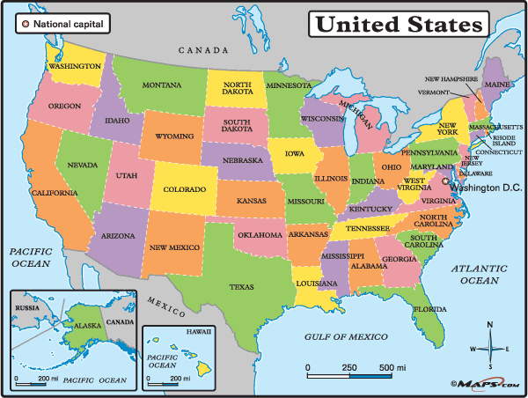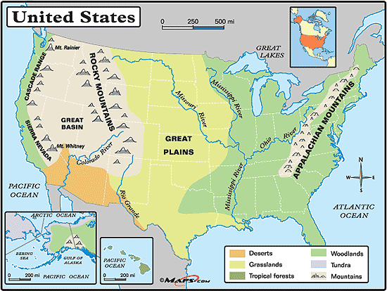

Another type of map is the political map. This type of map shows countries and states and their capitals. Borders are clearly marked. Political maps also show major cities in the states and countries. Many political maps use different colors to show different places.

Even though there are different types of maps for many different purposes, most maps have a few things in common. Maps have a title, a map key, a compass rose and a scale. Many maps also include a grid.

**Title**

Maps have titles, just like books. The title of a map tells you the subject of the map. You can use the title of the map to help you decide if the map will give you the information you need.

**Map Key**

The map key is an important part of the map. On most maps, the key is in a smaller box somewhere near the edge of the map. The key explains what symbols on the map stand for. Symbols are drawings or pictures on a map that stand for real things. Symbols can be colors, patterns, lines or special marks. They can stand for one thing on one map but mean something else on another map. It is important for you to study the map key before you begin using any map.

**Compass Rose**

The compass rose is a small drawing on the map that will help you find directions. It usually shows the four main, or cardinal, directions — north, south, east and west. A compass rose can also help you find the directions that are between the cardinal directions. These directions are called the intermediate directions. They are northwest, southwest, northeast and southeast.

**Map Scale**

The map scale helps you compare distances on a map with real distances in the world. You can use a map scale to help you find how far it really is between places on a map. Look at the map scale on the map to the left.

**Grid**

To make it easier for you to find specific places on a map, cartographers sometimes add lines that cross each other in a pattern. This pattern of crossing lines is called a grid. The lines form boxes on the map.

Some maps and globes use a specific grid system called latitude and longitude. This system was designed as a grid for the whole world, using the equator and prime meridian as central points. Any location on Earth can be described using this grid system.

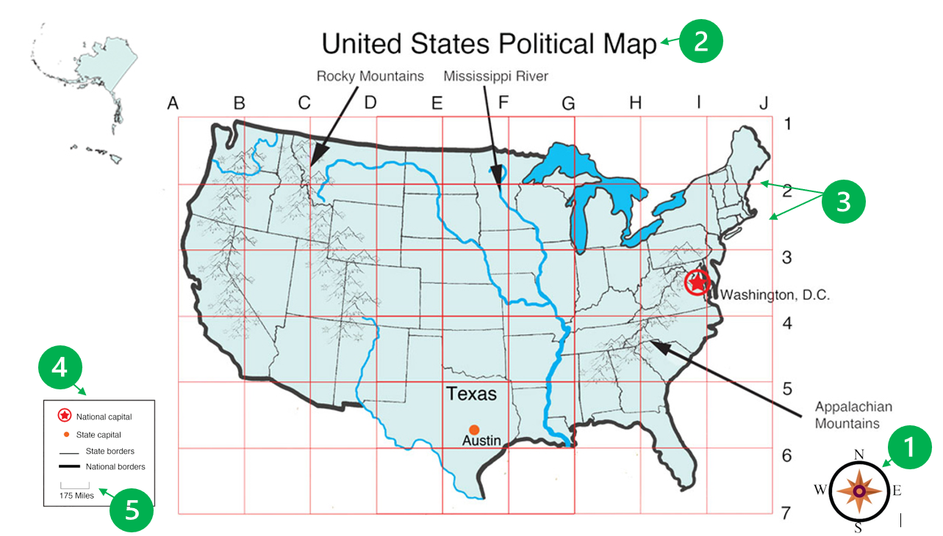

|  |
| --- |
| **Fill out the graphic organizer below using the map and information in this article.**   1. **Write a sentence in your own words describing the purpose of each map part.** 2. **Find each part of the map above. Match the name of each part by putting the green number in the last column.** |

|  |  |  |
| --- | --- | --- |
| **Map Part** | **Description** | **Green Map**  **Number** |
| **Title** |  |  |
| **Key** |  |  |
| **Compass Rose** |  |  |
| **Scale** |  |  |
| **Grid** |  |  |

|  |
| --- |
| **Directions Practice: Use the maps below and answer the questions that follow after each one. The compass rose has been labeled for you.** |

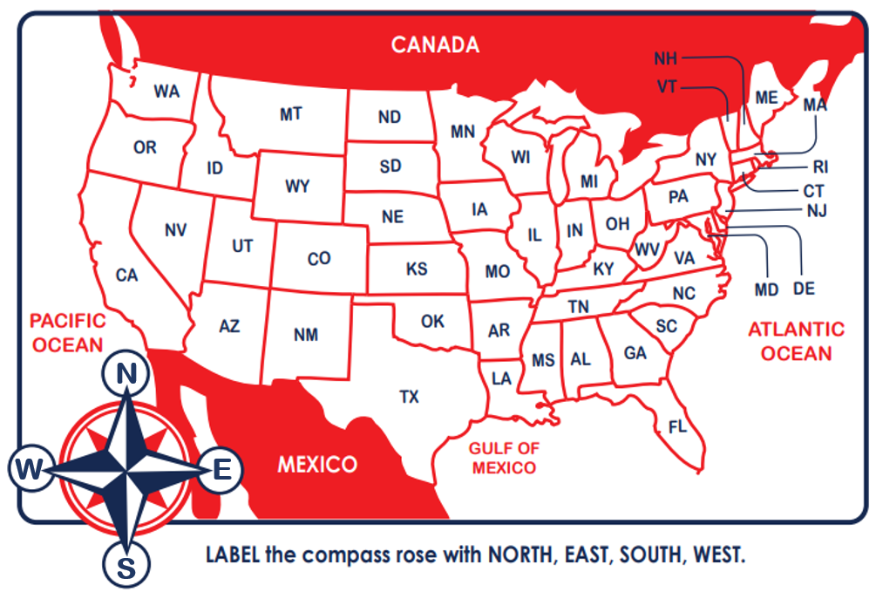

1. **What borders Texas to the North?**
2. **What borders Texas to the South?**
3. **What borders Texas to the East?**
4. **What borders Texas to the West?**
5. **From Texas, what direction is the Pacific Ocean?**
6. **What are three states that border the Pacific Ocean?**
7. **From Texas, what direction is Canada?**
8. **What states will you travel through to get to Canada from Texas?**
9. **From Texas, what direction is the Atlantic Ocean?**
10. **What state borders both the Atlantic Ocean and the Gulf of Mexico?**

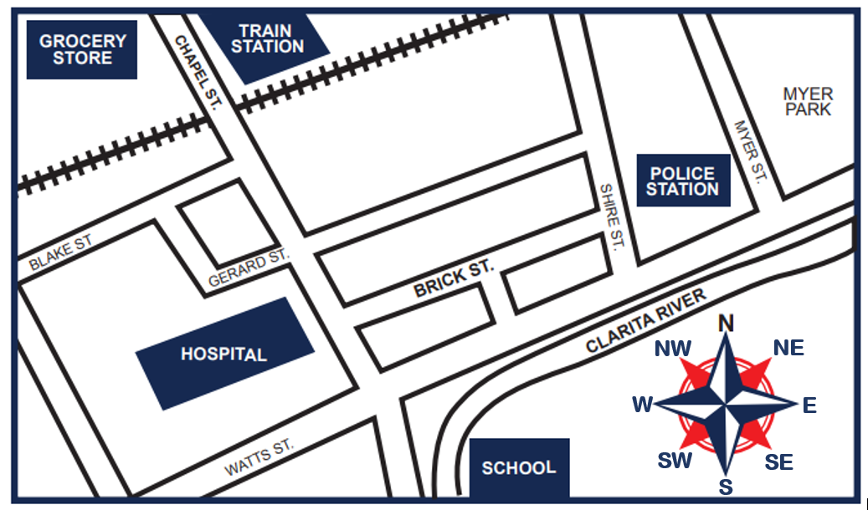

**Highlight the correct answer:**

1. **Amy is a police officer and goes to the grocery store after work. What direction should she travel to go to the grocery store?**

|  |  |  |  |
| --- | --- | --- | --- |
| **A. Northwest** | **B. South** | **C. Southwest** | **D. Northeast** |

1. **Karla goes to the park after school. What direction should she travel in to get to the park?**

|  |  |  |  |
| --- | --- | --- | --- |
| **A. Southeast** | **B. South** | **C. Southwest** | **D. Northeast** |

1. **Deangelo lives on Brick Street. He needs to head in what direction to go to the grocery store?**

|  |  |  |  |
| --- | --- | --- | --- |
| **A. North** | **B. Northwest** | **C. Northeast** | **D. Southwest** |

1. **David is a train conductor. He wants to meet an old friend at the Clarita River during his break. In what direction should he travel to go to the river?**

|  |  |  |  |
| --- | --- | --- | --- |
| **A. Southwest** | **B. Northeast** | **C. Northwest** | **D. Southeast** |

1. **Rika is a teacher and takes the train home. In what direction should she travel to get to the train station?**

|  |  |  |  |
| --- | --- | --- | --- |
| **A. Northeast** | **B. Southeast** | **C. Southwest** | **D. Northwest** |

1. **Gina wants to go to the east entrance of the police station. What street is east of the station?**

|  |  |  |  |
| --- | --- | --- | --- |
| **A. Shire St.** | **B. Blake Street** | **C. Myer St.** | **D. Gerard St.** |

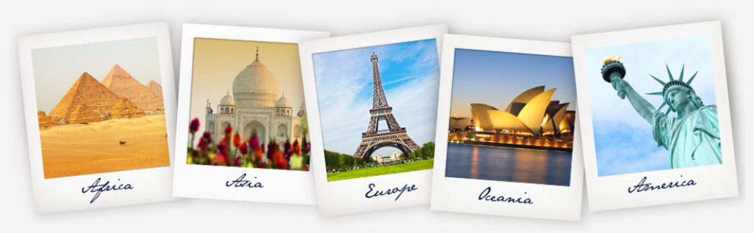

|  |
| --- |
| **Extension: Playing map games can be a fun way to begin to learn places on the map. Seterra is a website where you can play through a ton of differing ones. Each game comes with different “modes” that can help you learn the location, and test or challenge yourself.**  **Game Links**   * **Start with by learning** [**Continents and Oceans**](https://online.seterra.com/en/vgp/3188)**.** * **If you’re up for a challenge, try learning** [**all the U.S. States**](https://online.seterra.com/en/vgp/3003)**.** * **There are** [**tons more games**](https://online.seterra.com/en) **available to check out too!** |