**Summer Assignment: Geography**

**Objective:** The student will trace an element of popular culture back to it’s beginning and analyze how it has changed over time

**TEKS Alignment**

* WG.16(B) describe elements of culture, including language, religion, beliefs, institutions, and technologies
* WG.18(D) evaluate the spread of cultural traits to find examples of cultural convergence and divergence such as the spread of democratic ideas, language, foods, technology, or global sports

**Instructions:** Read through the following documents carefully. Respond to the following prompts:

1. With reference to its origin, purpose and content, analyze the value and limitations of Document 2 to historians studying the history of pop music. *Please respond in one full and complete paragraph.* (10 Points)
2. Use the sources to analyze how music becomes popular over time and space In other words, what key elements are essential to ensuring a music genre’s popularity around the globe? Why do some genre’s become popular and others do not? Why do some genres continue to be popular and other genres become less popular over time? *Please respond to this prompt in an essay 1-2 double spaced pages in length. Be sure to create a strong thesis statement directly answering the prompt and refer to at least two of the documents to support your claim.*  (20 Points)

**Document 1**

**Source:** Excerpted from How Hip-Hop Transformed New York, *The New York Times,* By Nelson George, April 16, 2018.

ON VALENTINE’S DAY, 1981, Deborah Harry was the headlining musical guest on “Saturday Night Live.” At the urging of Harry’s band, Blondie, and the band’s guitarist Chris Stein, “S.N.L.” booked the Bronx’s Funky 4 + 1 (four male rappers and pioneering female M.C. Sha-Rock) to perform their single “[That’s the Joint](https://www.youtube.com/watch?v=SVxk9PW62Vk)” for the show’s final number of the night. Harry’s rapped verse on “Rapture” was, for most people, a proxy introduction to hip-hop, but it was the Funky 4 + 1 that gave network television viewers the first true taste of what young New Yorkers had been experiencing in parks, subways and schoolyards for several years already.

This culture, just starting to be described under the umbrella phrase “hip-hop,” would emerge from its Bronx and Harlem origins during 1981 to ’83, engaging in a dialogue with the city’s other musical cultures that would extend its influence. The Funky 4 + 1’s 1980 “That’s the Joint” is a great example of how hip-hop’s particular vernacular helped propel the culture forward. The idea that something was “the joint,” meaning something was exciting or pleasing, had been street slang for several summers before this 12-inch single was released. That’s the Joint” is significant in another aspect: It took a New York street slang word and introduced it to the wider world, something that became a signature of rap records. Superlatives like “fresh,” “stoopid,” “def” and the ever enduring “dope” moved from the streets to recordings to advertising to daily usage. Hip-hop records like “That’s the Joint” literally remixed the way people talk.

The conclusion of the movie “Beat Street,” a feature film, was a big hit in West Germany, introducing early hip-hop culture — scratching, break dancing and rapping as the basis for casual conversation (“eat your eggs before I break your legs” goes one famous line from the film) — to an international audience.

This embrace of hip-hop by a wider (and whiter) audience sealed the genre’s fate in more ways than one. By 1981 a slew of new labels, all white-owned, began to displace the independent black-owned labels that put out the genre’s earliest efforts, but the language of music itself was also now irreversibly changed. Sugarhill Gang’s “Rapper’s Delight,” a surprise Top 40 hit in 1980, first introduced the phrase hip-hop and its overarching philosophy — “you don’t stop” — in the song’s opening lines. One year later, Blondie’s “Rapture” was a No. 1 single, and became the first video that referenced hip-hop culture to be in regular rotation on MTV, the new cable channel that launched in August of ’81. So when Deborah Harry said, “And you hip-hop, and you don’t stop,” the new-wave diva would be proved a prophet.

**Document 2**

**Source:** Mauch Matthias, MacCallum Robert M.Levy Mark and Leroi Armand M. 2015. The evolution of popular music: USA 1960–2010*. Published in the Royal Society for Open Science Academic Journal.*

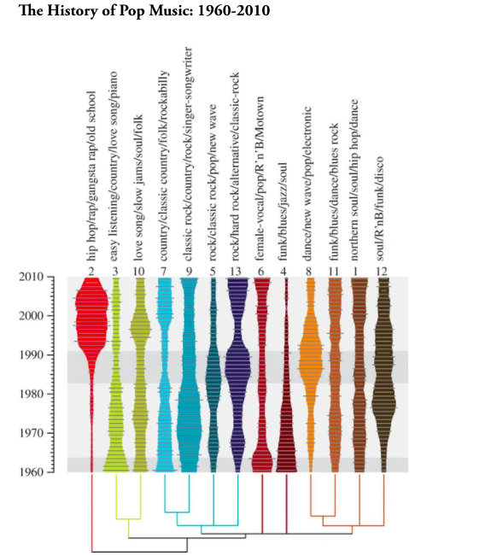

**Document 3**

**Source: Excerpted from** “**How K-pop became a global phenomenon**” *Vox Media,* By [Aja Romano](https://www.vox.com/authors/aja-romano), Updated Feb 26, 2018.

They call it Hallyu, the Korean wave: the idea that South Korean pop culture has grown in prominence to become a major driver of global culture, seen in everything from Korean dramas on Netflix to Korean skincare regimens dominating the cosmetics industry to delicious Korean tacos on your favorite local menu. And at the heart of Hallyu is the ever-growing popularity of K-pop — short, of course, for Korean pop music.

K-pop as we know it wouldn’t exist without democracy and television — specifically, South Korea’s reformation of its democratic government in 1987, with its accompanying modernization and lightening of censorship, and the effect this change had on television.

Prior to 1987, there were only two broadcast networks in the country, and they largely controlled what music South Koreans listened to; singers and musicians weren’t much more than tools of the networks. Networks introduced the public to musical stars primarily through weekend music talent shows. Radio existed but, like the TV networks, was under tight state control. Independent music production didn’t really exist, and rock music was controversial and subject to banning; musicians and songs were primarily introduced to the public through the medium of the televised talent show, and radio served as little more than a subsidiary platform for entertainers who succeeded on those weekend TV competitions.

These televised talent shows were crucial in introducing music groups to South Korean audiences; they still have an enormous cultural impact and remain the single biggest factor in a South Korean band’s success.

K-pop is unusual as a genre because it has a definitive start date, thanks to a band called Seo Taiji and Boys. Seo Taiji had previously been a member of the South Korean heavy metal band Sinawe, which was itself a brief but hugely influential part of the development of Korean rock music in the late ‘80s. After the band broke up, he turned to hip-hop and recruited two stellar South Korean dancers, Yang Hyun-suk and Lee Juno, to join him as backups in a group dubbed Seo Taiji and Boys.

Today there are numerous talent shows. Winning a weekend music show or weekly chart countdown remains one of the highest honors an artist or musical group can attain in the South Korean music industry.

Because of this dependence on live performance shows, a song’sperformance elements — how easy it is to sing live, how easy it is for an audience to pick up and sing along with, the impact of its choreography, its costuming — are all crucial to its success.

Hip-hop tends to be a [dominant part](https://www.youtube.com/watch?v=NHglTopVlKQ) of the K-pop sound, particularly among male groups, a trend that has opened up the genre to criticism for appropriation.

This gradual evolution suggests that part of the reason K-pop has been able to make international inroads in recent years is that it’s been able to push against its own rigid norms, through the use of modern themes and sophisticated subtexts, without sacrificing the incredibly polished packaging that makes it so innately compelling. That would seem to be a formula for continued global success — especially now that South Korea and its culture has the world’s attention. And from here, the future looks [fantastic, baby](https://www.youtube.com/watch?v=AAbokV76tkU).

|  |  |
| --- | --- |
| ***Question 1 Rubric*** | |
| *Failing (0-2 Points)* | The response does not reach a standard described by the descriptors below. |
| *Approaching (3-5 Points)* | The origin and purpose of the document is stated but may be missing two or more of the following; the author’s name, the date of publication, the type of document or intended audience and purpose.  Explanation of value of the document with respect to the origin, purpose, and content is attempted but requires clarity.  Explanation of limitations of the document with respect to origin, purpose, and content is attempted but requires clarity. |
| *Passing (6-7 Points)* | The origin and purpose of the document is stated but may be missing one of the following; the author’s name, the date of publication, the type of document or intended audience and purpose.  Value of the document with respect to the origin, purpose, and content is clearly explained but requires elaboration.  Limitations of the document with respect to  origin, purpose, and content is explained but requires elaboration. |
| *Masterful (8-10 Points)* | The origin and purpose of the document is clearly and accurately stated and includes the author’s name, the date of publication, the type of document and intended audience and purpose.  Value of the document with respect to the origin, purpose, and content is relevant, insightful and clearly explained.  Limitations of the document with respect to  origin, purpose, and content are relevant, insightful and clearly explained, |

|  |  |
| --- | --- |
| ***Question 2 Rubric*** | |
| *Failing (0-5 Points)* | The response does not reach a standard described by the descriptors below. |
| *Approaching (6-12 Points)* | The response lacks focus on the question.  References to the sources are made but at this level these references are likely to consist of descriptions of the content of the sources rather than the sources being used as evidence to support analysis. |
| *Passing (13-16 Points)* | The response is generally focused on the question.  Clear references are made to at least two of the sources, and these references are used as evidence to support the analysis. |
| *Masterful (17-20 Points)* | The response is focused on the question.  Clear references are made to at least two of the sources, and these references are used effectively as evidence to support the analysis. |