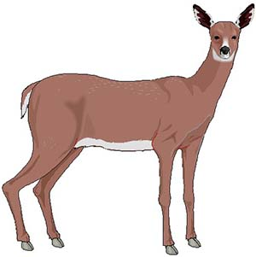

**Deer: Predation or Starvation?**

**Deer:  Predation or Starvation?**  
Introduction: In 1970 the deer population of an island forest reserve was about 2000 animals. Although the island had excellent vegetation for feeding, the food supply obviously had limits. Thus, the forest management personnel feared that overgrazing might lead to mass starvation. Since the area was too remote for hunters, the wildlife service decided to bring in natural predators to control the deer population. It was hoped that natural predation would keep the deer population from becoming too large and also increase the deer quality (or health), as predators often eliminate the weaker members of the herd. In 1971, ten wolves were flown into the island.  
The results of this program are shown in the following table. The **population change** is the number of deer born minus the number of deer that died during that year.   The herd population started at 2000 when this study began.

1. Calculate the number of deaths **(predation + starvation).**
2. To determine the deer population change, subtract the number of deaths from births **(births - deaths)**, this can be a positive number, indicating growth, or a negative number which indicates a population decline.
3. Calculate the deer population by adding/subtracting the population change from the population the year before
4. The first row (1971) has been completed for you as an example.
5. Graph the deer and wolf populations as two lines (color and label)

|  |  |  |  |  |  |  |  |
| --- | --- | --- | --- | --- | --- | --- | --- |
| Year | Wolf Population | Deer Births | Predation | Starvation | Number of deaths | Deer Population Change | Deer Population |
| 1970 | starting population, data unknown for prior year. | | | | | | <*2000* |
| 1971 | 10 | 800 | 400 | 100 | *500* | *+300* | *2300* |
| 1972 | 12 | 920 | 480 | 240 |  |  |  |
| 1973 | 16 | 1,000 | 640 | 500 |  |  |  |
| 1974 | 22 | 944 | 880 | 180 |  |  |  |
| 1975 | 28 | 996 | 1,120 | 26 |  |  |  |
| 1976 | 24 | 836 | 960 | 2 |  |  |  |
| 1977 | 21 | 788 | 840 | 0 |  |  |  |
| 1978 | 18 | 766 | 720 | 0 |  |  |  |
| 1979 | 19 | 780 | 760 | 0 |  |  |  |
| 1980 | 19 | 790 | 760 | 0 |  |  |  |

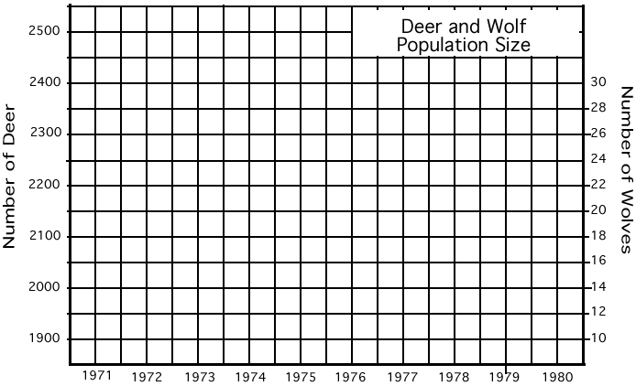

Analysis

1. Describe what happened to the deer population between 1971 and 1980.

2. When was the wolf population the highest? What is the relationship between the number of wolves and the number of deer?

3. What do you think would have happened to the deer on the island had wolves NOT been introduced?

4. **Zero population growth** occurs when a population has the same number of individuals entering the population (births) as those leaving the population (deaths). This results in very little change in the overall population numbers. In which year, was the deer population closest to ZPG? How do you know?

5. Most biology textbooks describe that predators and prey exist in a balance. This "**balance of nature**" hypothesis has been criticized by some scientists because it suggests a relationship between predators and prey that is good and necessary. Opponents of this hypothesis propose the following questions:

Why is death by predators more natural or "right" then death by starvation?  
How does one determine when an ecosystem is in "balance"?  
Do predators really kill only the old and sick prey? What evidence is there for this statement?

What is your opinion of the balance of nature hypothesis? Would the deer on the island be better off, worse off, or about the same without the wolves. Defend your position.