**Rising 10th Grade Summer Assignment for English II**

Stamped by Jason Reynolds and Dr. Ibram Kendi

Directions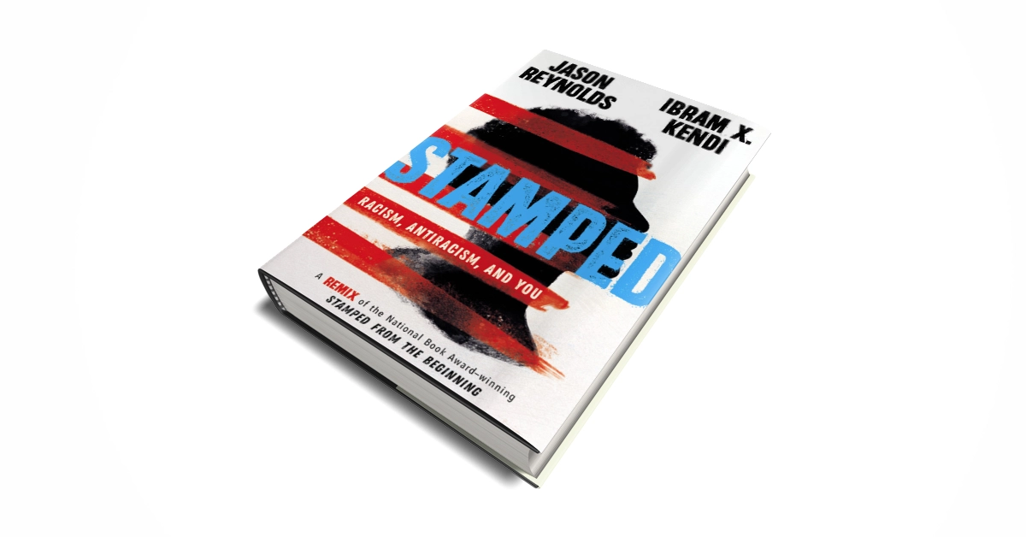

**Step 1 of 3: Read “Stamped” by Jason Reynolds and Dr. Ibram X. Kendi** [**(pdf)**](https://static1.squarespace.com/static/54823cade4b0090d4b36f575/t/5ef38a5df767b55175e7731b/1593018979197/Stamped+-+Racism%2C+Antiracism%2C+and+You.pdf)

* 1. Audiobook available on [youtube](https://www.youtube.com/watch?v=K8Seff-PFBg').
  2. Ensure you can answer 50% of these study questions by the first day of school

Study Questions **(if you can answer 50% of these questions you are understanding the novel)**

1. How do Reynolds and Kendi utilize historical examples to support their message? According to the authors, what are the impacts of continuing to leave out the history of racism and antiracism in the US in history books?
2. Discuss each of the three positions: assimilationist, segregationist, antiracist. In what ways do people, past and present, demonstrate their imperfections by acting in one or more of those positions?
3. Reynolds has given Gomes Eanes de Zurara the title “World’s First Racist.” In doing so, Reynolds spotlights the power of the written word and how it can be used as a force for evil. What is history? How is history much more than simply a recording of dates and facts that are significant only to the past?
4. In what ways is racism “woven into the fabric” of American institutions, if at all? Is racism in every part of American life? Where do you see evidence of this today, if at all?
5. Reynolds discusses The Souls of Black Folk by Du Bois and Du Bois’s concept of “double consciousness.” “A two-ness. A self that is Black and a self that is American” (p. 124). In what ways might people feel as if their identity is divided, in two parts? In what ways might people feel as if their identity is unified, or centered on one thing?
6. Marcus Garvey spotlighted the issue of colorism, its origins, and the dangers of it. Is colorism equally as destructive as racism? Why or why not?
7. Racism is so much a part of our lives that even everyday expressions that might seem innocuous (harmless) are in fact examples of the pervasive power of language and the ways words and phrases associate blackness with negativity. Examples include words and phrases such as black sheep, blackballing, blackmail, blacklisting, black mark, and blackout. Other words and phrases include minority, ghetto, thug, and inner city. Discuss the ways Reynolds sheds light on how Black people have worked collectively to resist such negativity. To what extent do all citizens of a democratic society have a responsibility to disrupt the racism that is embedded (included) in the English language?

**Step 2 of 3:** Create ONE non-literary representation of your choice and write a 250 word rationale explaining your representation. See options on the next page.



**Coat of Arms**

Create a Coat of Arms for an idea in the book. Write a half page rationale explaining your choices in the images and colors you chose for the Coat of Arms.

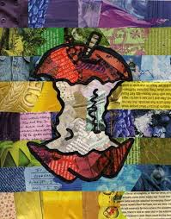

**Theme Collage**

Create a college made up of images, words, and symbols relating to the theme of the novel. Write a half page rationale explaining your choices.

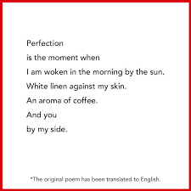

**Character Poetry**

Write three ten line poems about one or more of the ideas in the novel. Write a half page rationale explaining what the poems mean and how they relate to the characters or novel.

**Step 3 of 3:**

Write a 250 word rationale describing your engagement with the creative process by explaining your non-literary representation and its connection to the novel.

**Consider questions such as:**

1) How and why did you design your project the way you did?

2) What choices did you make in images, colors, placement of images, figurative language and how do those connect with the novel? Give details from the novel and its themes.

3)How does your overall project connect to the novel? Give details from the novel and its themes.

|  |  |  |  |  |
| --- | --- | --- | --- | --- |
| **MYP Language A Rubric** | | | | |
| **Task** | **1-2** | **3-4** | **5-6** | **7-8** |
| **Criterion C: Producing Texts** | Produces texts that demonstrate **limited** personal engagement with the creative process; demonstrates a **limited** degree of insight, imagination and sensitivity and minimal exploration of, and critical reflection on, new perspectives and ideas  selects **few** relevant details and examples from novel’s themes n connection to the prompt | produces texts that demonstrate **adequate** personal engagement with the creative process; demonstrates **some** insight, imagination and sensitivity and **some** exploration of, and critical reflection on, new perspectives and ideas  selects **some** relevant details and examples from the novel’s themes to develop ideas | produces texts that demonstrate **considerable** personal engagement with the creative process; demonstrates **considerable** insight, imagination and sensitivity and **substantial** exploration of, and critical reflection on, new perspectives and ideas  selects **sufficient** relevant details and examples from the novel’s themes to develop ideas. | **p**roduces texts that demonstrate a **high degree** of personal engagement with the creative process; demonstrates a high degree of insight, imagination and sensitivity and perceptive exploration of, and critical reflection on, new perspectives and ideas  Selects extensive relevant details and examples from the novel’s themes to develop ideas with precision |

**TEACHER FACING: Literary Analysis Writing Diagnostic**

**Summer Reading Literary Summative Assessment- Open Book**

**Choose ONE question to answer in a 500 word literary analysis.**

1. In what ways has the work you are studying explored the role of the individual in society, and what conclusions is it possible to draw from these explorations?
2. A literary work can be celebrated in one time or culture, but banned in another. In the work you are studying, discuss the ways that this work may be understood or received in different ways.

|  |  |  |  |
| --- | --- | --- | --- |
| **MYP Language A Rubric: Criteria A** | | | |
| **1-2** | **3-4** | **5-6** | **7-8** |
| i. provides limited analysis of the content, context, language, structure, technique and style of text(s) and the relationship among texts  ii. provides limited analysis of the effects of the creator’s choices on an audience  iii. rarely justifies opinions and ideas with examples or explanations; uses little or no terminology iv. evaluates few similarities and differences by making minimal connections in features across and within genres and texts | provides adequate analysis of the content, context, language, structure, technique and style of text(s) and the relationship among texts  ii. provides adequate analysis of the effects of the creator’s choices on an audience  iii. justifies opinions and ideas with some examples and explanations, though this may not be consistent; uses some terminology  iv. evaluates some similarities and differences by making adequate connections in features across and within genres and texts. | i. competently analyses the content, context, language, structure, technique, style of text(s) and the relationship among texts  ii. competently analyses the effects of the creator’s choices on an audience  iii. sufficiently justifies opinions and ideas with examples and explanations; uses accurate terminology  iv. evaluates similarities and differences by making substantial connections in features across and within genres and texts. | provides perceptive analysis of the content, context, language, structure, technique, style of text(s) and the relationship among texts  ii. perceptively analyses the effects of the creator’s choices on an audience.  iii. gives detailed justification of opinions and ideas with a range of examples, and thorough explanations; uses accurate terminology  iv. perceptively compares and contrasts by making extensive connections in features across and within genres and texts |

**Exemplars**

Question 1: Forthcoming

Question 2: Forthcoming