**Summer Assignment: Government/Economics**

**Objective:** The student understands the impact of participation in political processes at multiple levels

**TEKS Alignment:**

* USG.14(A) analyze the effectiveness of various methods of participation in the political process at local, state, and national levels
* USG.12(B) identify and define the unalienable rights

**Instructions:** Read through the following documents carefully. Respond to the following prompts:

1. With reference to its origin, purpose and content, analyze the value and limitations of Document 2 to historians studying the importance of the right to vote in the United States of America. *Please respond in one full and complete paragraph.* (10 Points)
2. Use the sources to evaluate the impact of voting in the United States. In other words, what do these sources say about why voting is important at national, state and local levels? *Please respond to this prompt in an essay 1- 2 double spaced pages in length. Be sure to create a strong thesis statement directly answering the prompt and refer to at least three of the documents to support your claim.* ***Thesis statement starters are provided for you on page six.*** (20 Points)

**Document 1**

**Source:** Why Your Vote Matters, from *National Geographic*

If you ever think that just one vote in a sea of millions cannot make much of a difference, consider some of the closest elections in U.S. history.

In 2000, Al Gore narrowly lost the Electoral College vote to George W. Bush. The election came down to a recount in Florida, where Bush had won the popular vote by such a small margin that it triggered an automatic recount and a Supreme Court case (Bush v. Gore). In the end, Bush won Florida by 0.009 percent of the votes cast in the state, or 537 votes. Had 600 more pro-Gore voters gone to the polls in Florida that November, there may have been an entirely different president from 2001-2009.

More recently, Donald Trump defeated Hillary Clinton in 2016 by securing a win of 304 Electoral College votes to 227. Although the election did not come down to a handful of votes in one state, Clinton actually won the national popular vote by nearly three million votes. But the concentration of Trump voters in key districts in "swing" states like Wisconsin, Pennsylvania, and Michigan helped seal enough electoral votes to win the presidency.

Your vote may not directly elect the president, but if your vote joins enough others in your voting district or county, your vote undoubtedly matters when it comes to electoral results. Most states have a "winner take all" system where the popular vote winner gets the state's electoral votes. There are also local and state elections to consider. While presidential or other national elections usually get a significant voter turnout, local elections are typically decided by a much smaller group of voters.

A Portland State University study found that fewer than 15 percent of eligible voters were turning out to vote for mayors, council members, and other local offices. Low turnout means that important local issues are determined by a limited group of voters, making a single vote even more statistically meaningful

**Document 2**

**Source:** "What the Black Man Wants" by Frederick Douglass. Excerpt of Speech Given at the Annual Meeting of the Massachusetts Anti-Slavery Society in Boston, April, 1865

We may be asked, I say, why we want it. I will tell you why we want it. We want it because it is our right, first of all. No class of men can, without insulting their own nature, be content with any deprivation of their rights. We want it again, as a means for educating our race. Men are so constituted that they derive their conviction of their own possibilities largely by the estimate formed of them by others. If nothing is expected of a people, that people will find it difficult to contradict that expectation. By depriving us of suffrage, you affirm our incapacity to form an intelligent judgment respecting public men and public measures; you declare before the world that we are unfit to exercise the elective franchise, and by this means lead us to undervalue ourselves, to put a low estimate upon ourselves, and to feel that we have no possibilities like other men.

**Document 3**

**Source:** The Voting Rights Act of 1965

Be it enacted by the Senate and House of Representatives of the United States of America in Congress [p*338] assembled, That this Act shall be known as the "Voting Rights Act of 1965."

SEC. 2. No voting qualification or prerequisite to voting, or standard, practice, or procedure shall be imposed or applied by any State or political subdivision to deny or abridge the right of any citizen of the United States to vote on account of race or color.

SEC. 4. (a) To assure that the right of citizens of the United States to vote is not denied or abridged on account of race or color, no citizen shall be denied the right to vote in any Federal, State, or local election because of his failure to comply with any test or device in any State…..

**Document 4**

**Source:** US Census Bureau. *Voting and Registration in the Election of 2008.* (2012)

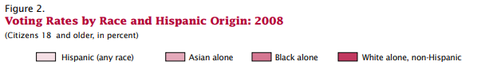

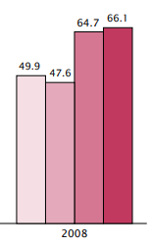

**Document 5**

**Source:** US Census Bureau. *Voting and Registration in the Election of 2016* .(2017)

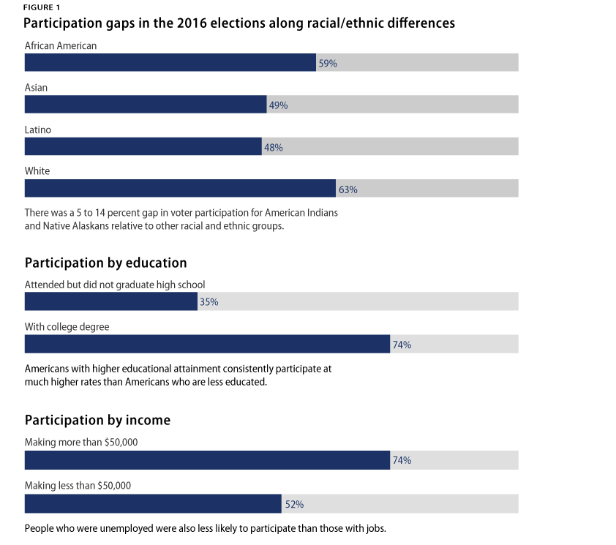

|  |
| --- |
| **Suggested thesis statement starters** |
| * Voting at multiple levels is important because…… * Because not all Americans have had the right to vote, it is important to…. * Because America is so large, voting at multiple levels is not as important as… * Although some people will tell their audience to vote/not to vote, it is not as/ very important to vote because... |

|  |  |
| --- | --- |
| ***Question 1 Rubric*** | |
| *Failing (0-2 Points)* | The response does not reach a standard described by the descriptors below. |
| *Approaching (3-5 Points)* | The origin and purpose of the document is stated but may be missing two or more of the following; the author’s name, the date of publication, the type of document or intended audience and purpose.  Explanation of value of the document with respect to the origin, purpose, and content is attempted but requires clarity.  Explanation of limitations of the document with respect to origin, purpose, and content is attempted but requires clarity. |
| *Passing (6-7 Points)* | The origin and purpose of the document is stated but may be missing one of the following; the author’s name, the date of publication, the type of document or intended audience and purpose.  Value of the document with respect to the origin, purpose, and content is clearly explained but requires elaboration.  Limitations of the document with respect to  origin, purpose, and content is explained but requires elaboration. |
| *Masterful (8-10 Points)* | The origin and purpose of the document is clearly and accurately stated and includes the author’s name, the date of publication, the type of document and intended audience and purpose.  Value of the document with respect to the origin, purpose, and content is relevant, insightful and clearly explained.  Limitations of the document with respect to  origin, purpose, and content are relevant, insightful and clearly explained, |

|  |  |
| --- | --- |
| ***Question 2 Rubric*** | |
| *Failing (0-5 Points)* | The response does not reach a standard described by the descriptors below. |
| *Approaching (6-12 Points)* | The response lacks focus on the question.  References to the sources are made but at this level these references are likely to consist of descriptions of the content of the sources rather than the sources being used as evidence to support analysis. |
| *Passing (13-16 Points)* | The response is generally focused on the question.  Clear references are made to at least two of the sources, and these references are used as evidence to support the analysis. |
| *Masterful (17-20 Points)* | The response is focused on the question.  Clear references are made to at least three of the sources, and these references are used effectively as evidence to support the analysis. |